In this module, you learned about the main psychological domains and also covered some of perspectives in psychology. You also learned relationship between brain and behavior about these perspectives you learned about (including psychoanalysis, behaviorism, cognitive psychology, subjective, the biological approach along with twenty century developments), and explain how you might explain the following human behaviors:

1. **Choose any one case (4 marks)**

Vishal while walking in the garden, is surprised by a giant snake and shrieks and jumps backward in surprise and horror. His heart is racing and his palms are sweating.

**Ans.**

Vishal's reaction to encountering a giant snake in the garden can be explained from various psychological perspectives, each offering a different lens through which to understand his behavior and the underlying neural and mental processes. Let's examine this scenario from several psychological perspectives:

**Biological Perspective:** From a biological perspective, Vishal's reaction can be explained by the activation of his autonomic nervous system. When he saw the snake, his brain quickly processed the visual information and sent signals to his amygdala, a key emotional processing center. The amygdala detected a threat and triggered the "fight or flight" response. This led to physiological changes, such as an increase in heart rate and sweating, as his body prepared to respond to the perceived danger. The relationship between brain and behavior here involves the amygdala's role in fear processing.

**Behaviorist Perspective:** Behaviorism would explain Vishal's behavior as a learned response to a specific stimulus, in this case, the snake. Vishal's shriek and jump backward can be seen as a conditioned response resulting from previous experiences or cultural conditioning that associates snakes with fear and danger. The behaviorist perspective emphasizes observable behaviors and how they are shaped through conditioning processes.

**Cognitive Perspective:** The cognitive perspective would focus on Vishal's thought processes and cognitive appraisal. In this case, his mind likely went through rapid cognitive processing. He recognized the snake, assessed it as a threat, and experienced a strong emotional reaction (fear). His behavior (shrieking and jumping backward) can be seen as a consequence of this cognitive appraisal and emotional experience.

**Psychodynamic (Psychoanalytic) Perspective:** From a psychodynamic perspective, Vishal's reaction might be explained as an expression of unconscious fears and anxieties. Sigmund Freud would suggest that Vishal's reaction is influenced by his unresolved, deep-seated conflicts and fears from his past. The sudden appearance of the snake may have triggered a repressed fear, leading to his emotional response.

**Subjective Experience Perspective:** The subjective expefaorience perspective would delve into Vishal's personal and unique experience. It would consider his subjective emotions and the meaning he attaches to encountering a giant snake. Vishal's response is not only about fear but also about his individual interpretation and emotional response to the situation.

**Q.** Explain behavior from different psychological perspectives and relationship between neurological event and mental process. Describe how different psychological approaches might explain behavior.

**Ans:**

Behavior can be explained from different psychological perspectives, each of which provides a unique framework for understanding human actions and experiences. These perspectives include:

**1. Biological Perspective:**

- This perspective focuses on the role of genetics, brain structure, and neurotransmitters in influencing behavior. It suggests that certain behaviors are a result of biological factors. For example, aggression may be linked to imbalances in neurotransmitters like serotonin.

**2. Psychodynamic Perspective:**

- The psychodynamic perspective, developed by Sigmund Freud, emphasizes the role of the unconscious mind and unresolved conflicts from childhood in shaping behavior. Behaviors are seen as manifestations of repressed desires and unresolved psychological conflicts.

**3. Behavioral Perspective:**

- Behaviorism, associated with figures like B.F. Skinner, emphasizes the influence of the environment and conditioning on behavior. It suggests that behavior is learned through reinforcement and punishment, and can be modified through conditioning techniques.

**4. Cognitive Perspective:**

- The cognitive perspective focuses on how mental processes, such as perception, memory, and problem-solving, influence behavior. It suggests that people's thoughts and interpretations of situations play a critical role in determining their actions.

**5. Humanistic Perspective:**

- Humanistic psychology, associated with Carl Rogers and Abraham Maslow, emphasizes personal growth, self-actualization, and the importance of subjective experiences. It suggests that behavior is motivated by a desire for self-improvement and the realization of one's potential.

**6. Social-Cultural Perspective:**

- This perspective examines how culture, social norms, and societal influences shape behavior. It recognizes that people's actions are often influenced by the cultural context in which they live.

**7. Evolutionary Perspective:**

- The evolutionary perspective suggests that behavior can be explained by considering how it might have provided an evolutionary advantage. It explores how behaviors have evolved to enhance survival and reproduction.

The relationship between neurological events and mental processes is a critical aspect of understanding behavior from a biological perspective. Neurological events refer to the activities and processes in the brain and nervous system. These events can have a significant impact on mental processes, which include thoughts, emotions, and consciousness. For example:

- Neurotransmitters like dopamine and serotonin can influence mood and emotional states.

- Brain damage or abnormalities in specific brain regions can lead to changes in cognitive functioning or behavior.

- The electrical activity in the brain, measured through techniques like EEG, can provide insights into mental processes and states of consciousness.

Different psychological approaches can explain behavior in various ways:

- The biological perspective emphasizes how neural processes, genetics, and the brain's structure can influence behavior.

- The psychodynamic perspective attributes behavior to unconscious conflicts and desires that stem from early experiences.

- The behavioral perspective focuses on how environmental factors and conditioning shape behavior.

- The cognitive perspective looks at how mental processes, such as memory and perception, drive behavior.

- The humanistic perspective emphasizes personal growth and self-actualization as motivators for behavior.

- The social-cultural perspective considers the impact of culture and societal norms on behavior.

- The evolutionary perspective explains behavior in terms of adaptations that enhance survival and reproduction.

1. **Adopt Wilhelm Wundt’**s approach to understanding the human mind and behavior. Invite three friends to listen to a piece of music, and ask each to introspect on their experience. Examine what each says about various aspects of the music. What does this exercise tell you about the subjectivity of introspection? In what ways do you think the method is worthwhile and in what ways is it limited?

**Ans**.

Wilhelm Wundt is considered one of the founders of psychology and was instrumental in developing the field of introspection. In this exercise, you invite three friends to listen to a piece of music and ask them to introspect on their experiences, examining various aspects of the music. Here's what this exercise reveals about the subjectivity of introspection and its limitations:

**Subjectivity of Introspection:**

* Each person's introspection is highly subjective, as it relies on their personal thoughts, feelings, and experiences.
* Each friend may describe different emotional responses to the music, highlighting the individual nature of perception and interpretation.
* Variability in their descriptions of aspects like melody, rhythm, and emotional impact underscores the subjectivity of introspection.

**Worthwhile Aspects of Introspection:**

* Introspection provides insight into individual thoughts and emotions, offering a deeper understanding of subjective experiences.
* It can be valuable for studying conscious awareness and mental processes, helping us explore the "inner world" of individuals.
* This method can uncover unique and nuanced aspects of perception and cognition.

**Limitations of Introspection:**

* Introspection is highly reliant on self-report, making it susceptible to biases and inaccuracies. People may not always accurately report their inner experiences.
* It is challenging to generalize findings from introspection to broader populations because individual experiences can vary widely.
* Introspection lacks objectivity and is difficult to quantify or measure, limiting its use in empirical research.

## Brain and behavior: (6 marks)

* 1. Your objective is to create an interesting visual (think: infographic) so that an outside observer could quickly learn link between brain and behavior by looking at it. It must include minimum 5 images and maximum 10 images and some text:

**Ans.**

Creating an infographic to illustrate the link between the brain and behavior is a great way to convey complex information in an engaging and visually appealing manner. Here's a simple infographic with five images and accompanying text to help an outside observer understand this connection:

**1. Introduction**

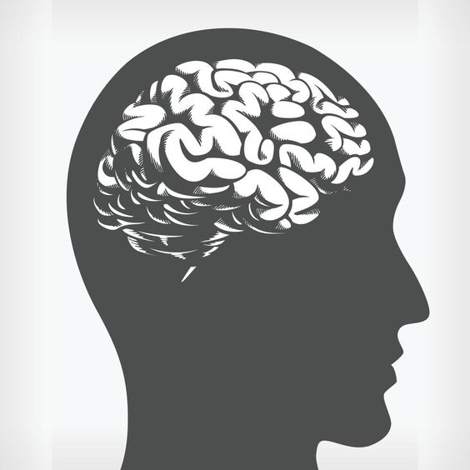

"The brain, our control center."

**2. Brain Structure**

The human brain consists of four lobes -

frontal lobe, 
parietal lobe, 
temporal lobe, 
occipital lobe.

The frontal and temporal regions of each hemisphere are each composed of 3 horizontal gyri; the parietal lobe consists of 2 lobules (quadrangular superior lobule and inferior lobule consisting of 2 semicircular gyri), the occipital region is composed of 3 irregular, less defined gyri that converge toward the occipital pole. 

The brain is divided into distinct regions, each responsible for different functions.

**3. Neurons**

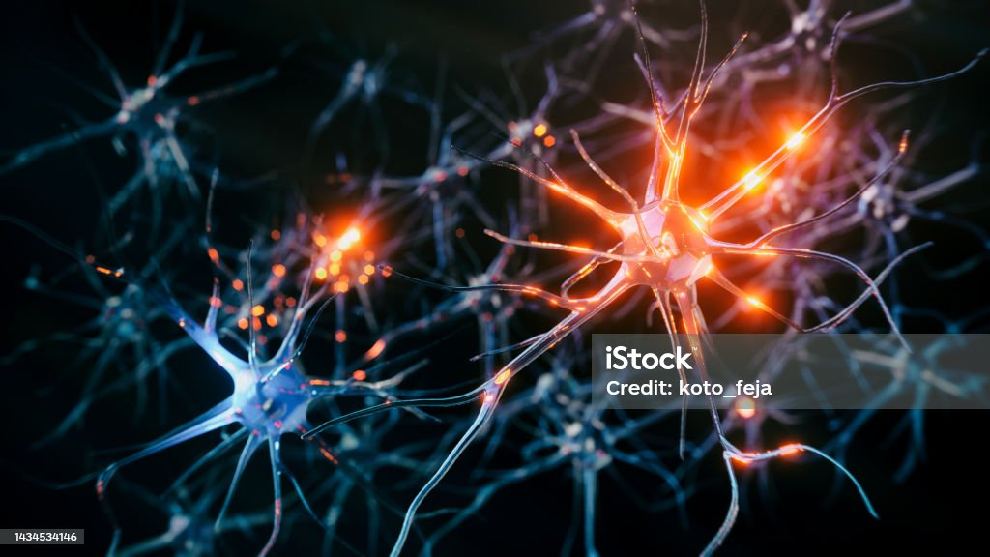

"Neurons are the brain's communication network, transmitting electrical signals.

**4. Chemical Messengers**

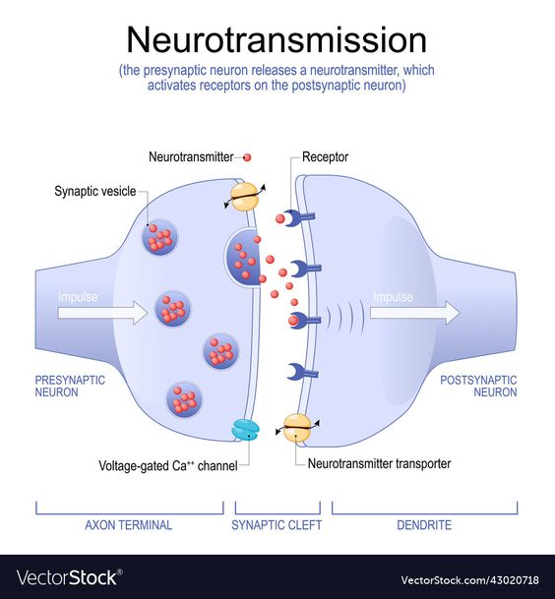

Neurotransmitters bridge gaps between neurons, affecting mood and behavior.

**5. Behavioral Outcomes**



The brain's activity influences our behavior, emotions, and decisions.

**6. Examples of Brain-Behavior Connection**



Reading, sports, and music are all driven by different brain regions.

## Answers these questions: Identify each part of the nervous system:

1. Exerts control over all parts of the body: **Central Nervous System(CNS)**.
2. Controls all voluntary movements, thoughts, and registration of incoming information: **Cerebral Cortex.**
3. The site where processing of all central nervous system activity takes place: **Brain.**
4. Main carrier of messages between the brain and the body: **Spinal Cord.**
5. Registers information and controls movements outside of the central nervous system: **Peripheral Nervous System(PNS).**
6. Takes charge over the body’s involuntary functions outside conscious awareness: **Autonomic Nervous System(ANS).**
7. Coordinates incoming information from the senses and sends instructions to the muscles and glands: **Central Nervous System(CNS).**
8. Increases heart rate in an emergency situation: **Sympathetic Nervous System.**
9. Stimulates digestion of food when the body is in a state of rest: **Parasympathetic Nervous System.**

## Neurotransmitters

Identify the purpose of each of the neurotransmitters listed below. Also, describe for each what might happen to a person if they have an excess amount or a lesser amount of the neurotransmitters.

1. **Acetylcholine:  
   Purpose:** Acetylcholine is involved in muscle movement, memory, and the regulation of the autonomic nervous system.

**Excess Amount:** Excessive acetylcholine can lead to muscle spasms, tremors, and cognitive disturbances.

**Lesser Amount**: A deficit in acetylcholine can result in muscle weakness, memory problems, and difficulty in regulating autonomic functions.

1. **GABA:**

**Purpose:** GABA is the main inhibitory neurotransmitter in the central nervous system, regulating anxiety, stress, and promoting relaxation.

**Excess Amount:** An excess of GABA can lead to excessive sedation, drowsiness, and decreased cognitive function.

**Lesser Amount:** Insufficient GABA may result in heightened anxiety, stress, and difficulty in relaxing.

1. **Glutamate:  
   Purpose:** Glutamate is the main excitatory neurotransmitter, playing a key role in learning, memory, and synaptic plasticity.

**Excess Amount:** Excessive glutamate can lead to neurotoxicity and is associated with conditions like migraines and neurodegenerative diseases.

**Lesser Amount:** A deficiency in glutamate may impair cognitive function, memory, and synaptic plasticity.

1. **Norepinephrine:**

**Purpose:** Norepinephrine is involved in the "fight or flight" response, alertness, and mood regulation.

**Excess Amount:** Excess norepinephrine can lead to anxiety, hypertension, and increased heart rate.

**Lesser Amount:** A deficiency in norepinephrine can result in fatigue, low mood, and difficulty concentrating.

1. **Dopamine:**

**Purpose:** Dopamine plays a role in reward, motivation, and movement control.

**Excess Amount:** An excess of dopamine is associated with conditions like schizophrenia and addiction.

**Lesser Amount:** A dopamine deficiency and may lead to decreased motivation and pleasure.

1. **Serotonin:**

**Purpose:** Serotonin regulates mood, appetite, and sleep, and it is often referred to as the "feel-good" neurotransmitter.

**Excess Amount:** Excessive serotonin can lead to serotonin syndrome, resulting in agitation, confusion, and muscle twitching.

**Lesser Amount:** A serotonin deficiency is associated with conditions like depression and may result in mood swings, sleep disturbances, and altered appetite.

1. **Endorphin:**

**Purpose:** Endorphins are natural painkillers and mood enhancers produced in response to stress or physical activity.

**Excess Amount:** An excess of endorphins is rare but can lead to a reduced sensitivity to pain and an artificially elevated mood.

**Lesser Amount:** Insufficient endorphins may result in increased pain sensitivity and a lowered ability to cope with stress.

1. **Oxytocin:**

**Purpose:** Oxytocin is involved in social bonding, maternal behaviors, and the regulation of uterine contractions during childbirth.

**Excess Amount**: Excessive oxytocin may lead to overly strong uterine contractions, which can be harmful during labor, and potentially contribute to social attachment disorders.

**Lesser Amount:** A deficit in oxytocin can affect social bonding and maternal behaviors, potentially leading to difficulties in forming close relationships and maternal attachment.

## Parts of the Endocrine System

1. Major chemical in the endocrine system: **Hormones.**
2. Regulates the pituitary gland: **Hypothalamus.**
3. The body’s “master gland”: **Pitutary Gland.**
4. Female reproductive organ: **Ovary.**
5. Organ that produces hormones involved in sugar metabolism: **Pancreas.**
6. Gland that controls metabolic rate: **Thyroid Gland.**
7. Nervous system organ that is also in the endocrine system: **Brain (specifically pituitary gland).**
8. Male reproductive organ: **Testes.**
9. Type of regulation in the endocrine system: **Feedback Regulation (Homeostasis).**
10. Gland involved in controlling bodily size: **Pitutary Gland (through growth hormone).**
11. Involved in regulating body’s reaction to stress: **Adrenal Gland.**

# Parts of the brain

Describe one daily routine that you do that uses each of these parts of the brain (you can use one example or five separate examples).

1. **Cerebellum:**

In the morning, as I reach to turn off the alarm clock, swing my legs out of bed, and stand up, my cerebellum ensures that my movements are smooth and well-coordinated.

1. **Hypothalamus:**

Before going to college, I have breakfast. Hypothalamus helps regulate my appetite and thirst, ensuring I feel hungry and thirsty at the appropriate times. It also helps maintain my body temperature.

1. **Reticular formation:**

During my workout session in the gym, the reticular formation keeps me awake and attentive, ensuring that I'm focused on my exercises and not drifting into a drowsy state.

1. **Limbic system:**

Throughout the day, I experience a range of emotions on people’s face, and the limbic system plays a key role in recognizing, processing, and expressing these emotions.

1. **Frontal Lobe:**

The frontal lobe is responsible for higher cognitive functions, including planning and decision-making. Before starting my exercise routine, I made a conscious decision to allocate time for it. Throughout the routine, the frontal lobe is engaged in planning the order of exercises and making real-time decisions to adjust my movements for optimal results.

# Activities in the parts of the brain

Identify each part of the nervous system associated with each of the following activities:

* 1. Balancing on a tight rope: **Vestibular System.**
  2. Clapping your hands: **Somantic Nervous System.**
  3. Waking up when the alarm goes off: **Central Nervous System.**
  4. Feeling hungry: **Hypothalamus.**
  5. Understanding your psychology professor’s lecture: **Central Nervous System (primarily cerebral cortex).**
  6. Planning your route to drive home: **Central Nervous System.**
  7. Becoming enraged when someone cuts you in line: **Limbic System.**
  8. Talking on your cell phone: **Somantic Nervous System.**
  9. Hearing your favorite music group on your smartphone: **Auditory System.**
  10. Feeling drops of rain on your face: **Sensory Receptors.**
  11. Seeing a traffic light change color: **Visual System.**
  12. Breathing while you sleep: **Autonomic Nervous System.**
  13. Pushing the “open” button on the computer when a page has download: **Somantic Nervous System.**

**Student Handout**

Below is a diagram of the brain, taken from the book. Try to remember and write down the name of each region and say a few words about what is known about its role in cognition.

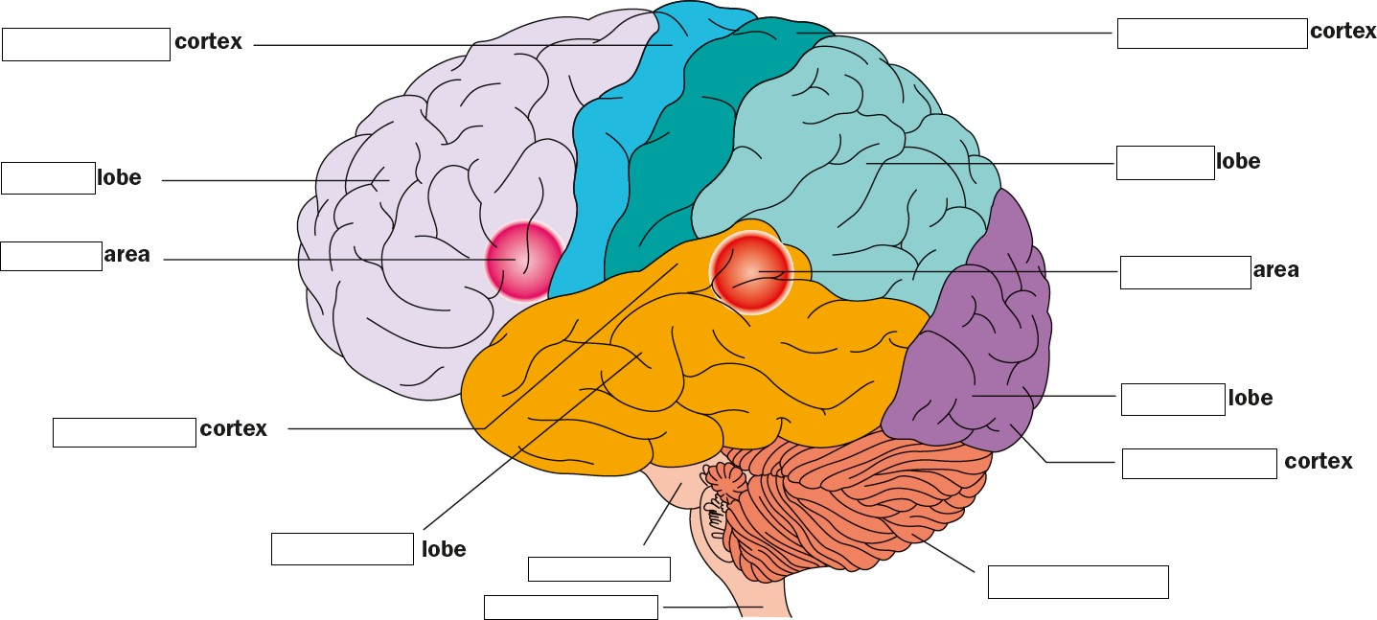

Parietal

Primary Motor

Primary Somatosensary

Primary Visual

Cerebral Cortex (cerebellum)

Medulla oblongeta

Occipital

Wernike’s

Temporal

Prefrontal

Broca’s

Frontal

Spinal Cord